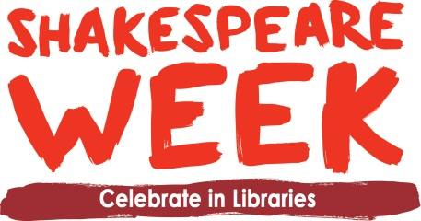
Resource Pack Instructions
Whether you are having a Shakespeare family event, drop-in activities during the week or class visits, these downloadable resources created by the brilliant Steve Smallman will help you. Print copies off as required and have scissors, plain card, paper and colouring materials all to hand if possible.
1: Shakespeare Trail
The trail is designed to be used in conjunction with the promotional film about young Will called “Unwillingly to school”.
It comprises 8 full colour images that can be displayed around the library for children to find. There are 4 characters that children will identify from the film - young Will, Will’s mum, Will’s dad and his teacher with the head of a donkey. There are also 4 animals linked to Shakespeare’s plays complete with quotes - a donkey; a snake; a bear and a lion.
There is also a trail sheet. Children can use it to tick the images off as they find them.
2: Headband characters
An A4 sheet with outlines of four animals featured in the plays. Children can colour these in and then attach them to strips of paper / card to fit around their heads. (You will need to provide this too).

3: Theatre outline
Children can design a stage set in the theatre outline.

4: Scroll outline
Encourage children to write their idea for a play, a story or a few elements of dialogue. This can be used for a range of writing ideas.

5: Dressing characters
Outlines of Tudor children a boy and girl – children can draw the clothes they would be wearing – encourage them to use books or websites about Tudors to get their ideas. They can add facial features too.

6: Poetry
Encourage children to write poems describing the animals in Shakespeare’s plays using the model on the sheet if they need particular inspiration.

7: Shakespeare Chatterbooks Pack
A downloadable activity pack for Chatterbooks groups full of brilliant ideas for further activities!

